Nourah Alazzaz
NahedAlmaimoni
ENG316
27/9/2020
Outline
Introduction:
Hook : fact
Background information
Thesis: I clarified my point and the other side
Main idea one: my side1: human translation is costly
A) human translation mostly correct
b) it is a good and worthy translation.
Main idea two: my side 2: development of human translation
a)In the begging they were fewer and specialized
b) The human translator should know the synonyms, verbs of the other language.
c)Understanding the culture
Main idea three: the other side : translation Machin faster and cheaper
A) A lot of mistakes.
b) Not creative in the translation.
c)Use the obvious meaning
conclusion:
summarizewriter argument.
I mention why the other side should agree with my side.
Nourah Alazzaz
NahedAlmaimoni
ENG316
27/9/2020

Machine Translation vs. Human Translation
Which is more important?

For so many years, translate words or texts became a part of language learners' daily life, it made their journey easier. There are several types of translation such as machine translation, human translation, and computer-assisted translation. Human translation is more specific than any type of translation because translator understands the source of the cultural text. This is unlike machine translation that adapts the translation method of word to word. Some people prefer human translation because of its professionalism and being cheaper.

“Translation is not a matter of words only: it is a matter of making intelligible a whole culture” (Burgess2012). Although human translation is pricey and expensive sometimes, it provides the translation quality in the best way. Furthermore, people wouldn’t turn away their money for a good and worthy translation. The process of translation should be creative but machine lacks creativity. Therefore, the translator should be aware of cross culture sensitivity. To add to this, a good translation should sound natural and be fluent. Only human translators can sound natural and be fluent and convey the source language style and tone perfectly to the target audience.

Over a couple of years ago, human translation became available in all languages of human. This made it possible for many people including translators learn new vocabularies by trying to look for synonyms, verbs and conjunction. Since many words have more than one meaning, machine translations tend to give only the first meaning and ignore the other meanings and this makes it hard to relate to machine translation. Therefore, human translation makes it for people to understand different meanings of vocabularies unlike machine translation which gives only the first meaning of the vocabularies and leave people with a huge vocabulary bank.

Some people argue that machine translation is faster, cheaper and free. This is because machine translation can give a perfect text that is translated and will not spend time looking for vocabulary meanings in a dictionary. However, mistake is an important thing that any translation should consider. For instance, when compared to machine translation, human translation tends to give fewer mistakes. Besides, human translation can incorporate similes and metaphors since a translator can be creative. Therefore, human translation will not be replaced by machine translation as many scholars have argued that “the professionalism quality of humans will not be reached by machine translation.” (Melby, 1995)

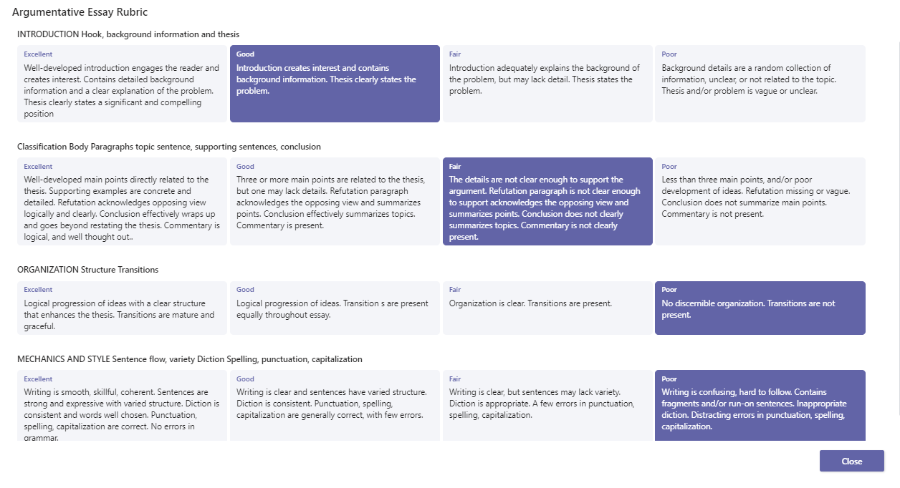
In conclusion, machine translation is a better option when words or small phrases are being translated. However, machine will never substitute human when it comes to translation. The culture of the target audience is easily understood by a translator something a machine cannot do. Human translation can seem to be expensive but in the long run, it is quite cheap compared to machine translation which needs human intervention.

Red- Complex
Blue- Compound
Green- Simple

